
To: Armin Eilaghi
From: Honda EV Conversion - Team P1
Date: March 31, 2023
Re: Finalized Testing Plan
Introduction:

The following document describes the final testing plan for the Honda EV Conversion senior capstone. The goal of this document is to provide the client with an outline for the expected tests and procedures that will take place upon the successful completion of the final design. This document will also provide the team with detailed testing procedures to follow when performing the various tests and offer material to help determine if the product successfully meets the design requirements.

Design Requirements Summary:

From conversations with the client, Brian Gillespie, the team collected the customer requirements and created the engineering requirements. Table 1 illustrates the design requirements that will be used to formulate the testing procedures and evaluate the designs of the EV conversion kit.

Table 1: ERs developed using CRs
Customer Requirement | Developed Engineering Requirement
CR1 - Battery life sufficient for average commuter | ER1 - Increase range greater than 100 miles
CR2 - Six or more batteries in vehicle | ER2 - Increase battery capacity greater than 40 kWh
CR3 - Consumer sellable (safe and durable) product | ER3 - Reduce cost of production ($)
CR3 - Consumer sellable (safe and durable) product | ER4 - Maximize power output 300 hp
CR3 - Consumer sellable (safe and durable) product | ER5 - Maximize torque output 250 ft-lb
CR4 - Lightweight | ER6 - Decrease weight less than 3000 lbs.
CR5 - Cooling system for electric motor | ER7 - Cool components to less than 200°F
CR6 - Compatibility with similar vehicle models | ER8 - Reduce number of mounts, 5 or less

Top Level Testing Summary:

From the six customer requirements and eight engineering requirements, ten separate tests were designed to determine the validity of the design the team made. The layout of the tests and the customer and engineering requirements they will evaluate are shown below in table 2. With the completion of these eight tests the team will have a comprehensive understanding of how well the design successfully operates.

Table 2: Design Testing Layout
Experiment/Test | Relevant DRs
EX1 – Weight Test | CR4, ER6
EX2 – Battery Capacity Test | CR1, CR2, ER1, ER2
EX3 – Pre-Drive Electrical Test | CR3
EX4 – Pre-Drive Rigidity Test | CR3
EX5 – Range Test | CR1, CR2, ER1, ER2
EX6 – Production Cost Test | CR3, ER3
EX7 – Compatibility Test | CR6, ER8
EX8 – Cooling Test | CR5, ER7
EX9 – Power Output Test | CR3, ER4
EX10 – Torque Output Test | CR3, ER5

Detailed Testing Plans:

The detailed testing plan will provide an in-depth look at the eight tests previously mentioned in Table 2. This section will provide a summary for each test being run and the necessary tools and equipment needed to operate the test. It will also explain what the team will use the results for and what the results will mean within the scope of the project. After a summary for each test is written, the detailed procedures below will illustrate the specific nuances of each test. The expected results are detailed with backing equations supporting the specific test; these hypothetical results are then contrasted against the experimental results to validate the calculations.

EX1 – Weight Test Summary

The weight test captures the current weight of the electric vehicle to satisfy the customer and engineering requirement of lightweight and vehicle weight below 3,000 pounds. The test will determine the overall weight of the vehicle, motor, batteries, mounts, and electrical systems. The equipment required for this test will be a bathroom scale to measure all individual parts going into the vehicle as well as the parts that have been removed from the vehicle. The team researches the weight of the bigger components too heavy to easily measure and adds the values to the gross weight. Since the team does not have access to a full vehicle scale individual components are weighed to calculate the gross weight of the vehicle. The team compares this gross calculated weight with a vehicle scale, after finding a shop that has one, that can provide an accurate reading. The variables in this test are gross weight in pounds and variables for each individual component.

Procedure

The procedure for this test follows the sequential steps below and may change slightly as the team evaluates results.
- Weigh electrical components, batteries, mounts, and any miscellaneous accessories.
- Research and determine official weight of vehicle, original engine that have been removed, and Tesla small drive unit.
- Calculate gross weight of assembled vehicle by adding together individual component weights.
- Source mechanic shop or quarry to utilize their vehicle measuring system.
- Weigh vehicle on larger scale and compare to previously calculated.

Results

The results that the team are looking for is a gross weight of the vehicle using all required items needed to drive. Performing a summation calculation of the components determines the team’s estimate of the gross weight (Equation 1). The comparison gross weight will use either a vehicle weighing system or using a quarry truck weighing system.

${Weight}_{Total}=W_{Body}+W_{Motor}+W_{Batteries}+W_{Mounts,Brackets}-W_{OE Drivetrain}-W_{OE Fuel Tank}$ (Equation 1)

Conclusion

This test will confirm that the lightweight and 3,000-pound weight cap requirements satisfy the needs of the customer and the project requirement. The team expects the weight to be below 3,000 pounds from the results collected during the project thus far.

EX2 – Battery Capacity Test Summary

The battery capacity test determines the battery life and validates the customer requirements. These requirements are sufficient battery life for an average commuter and at least six batteries stored within the vehicle. The test also verifies the engineering requirement of a range greater than 100 miles and a battery capacity of 40 kWh or more. There is no equipment required to determine the capacity of the battery, but voltage of each battery module is tested with a multimeter. This test is primarily to determine the overall capacity of the system and assess the actual voltage supplied to the motor. Electric vehicles use roughly 0.2-0.5 kWh of battery per mile driven and this fact will determine the expected range in the following test. The variables isolated for this test are quantity of batteries and kilowatt capacity of each battery. During the test the total voltage and kilowatt hour capacity is determined.

Procedure

The procedure for this test follows the steps below and may change slightly as the team evaluates the results.
- Determine the final quantity of batteries that will be included in the vehicle.
- Use the positive and negative lead on the multimeter to test a fully charged battery.
- Determine the official capacity of a single battery and total voltage supplied to the electric motor.

Results

The team needs a total kilowatt rating of the entire battery system. Equation 2 calculates the full capacity of six batteries in the vehicle.

$W_{Total}=N*W_{Battery}$ (Equation 2)

Conclusion

This test will confirm that the design will meet the customers’ desire for a 40 kilowatt or more system. This test also verifies that the batteries supply enough voltage to run the electric motor. The team is confident that we will meet this design requirement.

EX3 – Pre-Drive Electrical Test

This test ensures the safety of the electrical components before beginning the initial drive of the vehicle. The test proves the customer requirement of a consumer sellable and safe product. The equipment used to perform this test will be a voltmeter and a car lift to be able to evaluate the electrical components throughout the system while the motor is able to spin the wheels. The variables isolated for this test will be the voltage and amperage of the subsystems in the vehicle during charging and operation. Since this test is qualitative rather than quantitative, no variables are necessary to determine whether the electrical system is safe to operate the vehicle.

Procedure

The procedure for this test follows the steps below and may slightly change as the team evaluates the results.
- Plug in the charger and measure the voltage and amperage flowing into the system.
- Once charged, check all subsystems to ensure no power is reaching where it’s not supposed to.
- Measure voltage and amperage at contactor box.
- Turn vehicle on and test voltage and amperage at all subsystems again.
- Put vehicle into drive and test motor draw as well as all other subsystems.
- Accelerate multiple times at different levels and measure draw in all systems.

Results

The team wants to determine whether the vehicle is safe to drive based on the design and use of the electronics and the related components. There will be no equations needed for this test as it will only need the collection of data. All systems in the design will have varying voltage and amperage and the results will be based on how safely the electrical components can handle this.

Conclusion

From this test the team will understand better potential safety hazards that the vehicle will be subject to. And will determine if it is safe to continue onto the driving portion of the testing.

EX4 – Pre-Drive Rigidity Test

This test is to further ensure the safety of the electrical components before beginning the initial drive of the vehicle. It will further prove the customer requirements of a consumer sellable product and safe product. There is no equipment needed for this test as all results are visually determined. The only variables isolated during this test will be the acceleration of the motor under load and the angle of twist caused during acceleration.

Procedure

The procedure for this test follows the steps below and may slightly change based on the results the team collects.
- Perform this test in tandem with pre-drive electrical test.
- Accelerate the vehicle in increasing levels until reaching full acceleration.
- During acceleration visually inspect the motor mounts for twisting during load.
- If there is twisting determine if it is an acceptable amount.
- Ensure motor mounts return to normal once the loading is finished.
- Repeat this process numerous times to ensure no change due to fatigue.

Results

The team determines whether the design can handle the motor accelerating for an extended period. There are no equations needed for this test as it will be based on visual inspections. The team expects success since the steel mounts use standard tesla mounting points as opposed to the original aluminum mount.

Conclusion

From this test the team determines if the design is ready to move onto the driving portion of the tests and ensures that there will be no catastrophic failures during those tests.

EX5 – Range Test Summary

The range test determines the range of the vehicle sufficient for an average commuter and that there are six or more batteries included in the vehicle. These are the customer requirements included in this test and the engineering requirements are a range greater than or equal to 100 miles and a battery capacity greater than or equal to 40 kWh. The focus of this test is on the real-world range in miles that the vehicle can drive. As stated in test 2, the battery capacity has a direct impact on the range results and provides the team with estimates of the expected range. The equipment required for this test will be an accurate odometer, safe and controllable road conditions, and a truck with a trailer as a safety precaution in case the vehicle runs out of charge on the road. For this test the team will be isolating the variable of range in miles using multiple different road conditions including city, highway, and combination scenarios. The team calculates an average range for all conditions and a battery capacity efficiency value.

Procedure

The procedure for this test follows the steps below and may change slightly depending on the results collected by the team.
- Research and acquire estimates efficiency of the Tesla small drive unit.
- Use Tesla SDU efficiency and previously found total battery capacity to determine expected range of vehicle.
- Plan 3 different routes roughly the expected range of the vehicle these 3 routes should predominately include the following.
  - Route 1 should be city streets attempting to obtain a 30mph average speed with frequent stops for streetlights.
  - Route 2 should be highways with little to no traffic maintaining 65mph average speed.
  - Route 3 should be a mix between city and highway driving.
- Drive these 3 scenarios 3 times to obtain an average of all 3 routes.
- An efficiency average for the motor is calculated for each driving condition.
- An overall average from all 9 trips is calculated.

Results

The results that the team is looking for is the expected range that the vehicle is expected to maintain during the life of the design. The only needed equation for this test is an average of the 9 tests to determine the average range achieved and can be seen as equation 3. This test is expected to be a success based on the battery capacity we expect to achieve.

${Range}_{Ave}=(Test1+Test2+Test3)/3$ (Equation 3)

Conclusion

From the test the team will finally know the real-world range of the system designed allowing us exciting data to provide the client and for the client to give to customers.

EX6 – Production Cost Test Summary

The production cost test will provide evidence of the successful completion of a consumer sellable and safe product customer requirement as well as the need to have production products cost less than $4,000 engineering requirement. For this test the team will calculate the cost of materials and time needed for the assembly of one kit which will require a stopwatch, welder, sheet metal bender, and powder coat machine all of which are readily available to the team. The variables isolated for this test are quantity of bolts, nuts, washers, and other miscellaneous parts required for assembly as well as the surface area of the sheet steel. As well as the time in minutes it takes for an employee of Hasport Performance to assemble the product. These variables calculate the cost of materials and hourly wages the company needs to invest in the product to determine a realistic selling price to a customer.

Procedure

The procedure for this test follows the steps below and may change slightly when the team evaluates the results.
- Create a final bill of materials.
- Research hardware prices.
- Calculate the total sheet steel square footage and compare it to the standard price per square foot of sheet steel.
- Add the total price of material and hardware together.
- During the assembly of the product an employee of Hasport will be timed to determine the overall time of production.
- The cost of the employee added to the cost of materials and an extra 30 minutes added for the shipping of the final product determines the cost of production.
- A discussion with the client to determine the expected profit margin and determine a price point to sell the motor mounts for.

Results

The team wants to understand the expected cost of one kit and the potential marketable price. The only equation needed for this test will be adding the cost of material and hardware and the cost of paying the employee to assemble the kit (Equation 4). The team expects this test to be successful as basic calculations have been done and the goal price point is $4,000 for the kit price.

${Cost}_{Total}={Cost}_{Hardware}+Cost_{Material}+Cost_{Employee}$ (Equation 4)

Conclusion

From this test the team will be able to provide information to the client about what a reasonable selling price would be and this will be valuable knowledge for the client’s business.

EX7 – Compatibility Test Summary

The compatibility test will provide evidence of the successful completion of being compatible with similar vehicle models customer requirement as well as the engineering requirement of keeping the number of mounts below a quantity of 5. Keeping the quantity of mounts as low as possible will increase the number of vehicle models that the kit will be compatible with. There will be no equipment needed for this test other than having access to multiple 1990s Honda models with Hasport Performance has an abundance of Hondas available to the team. No variables are isolated for this test and the variable calculated from this test is the expected range of vehicles compatible with the kit.

Procedure

The procedure for this test follows the steps below and may change based on the evaluates results.
- Install final kit design into the teams Honda Del Sol.
- Understand installation process and clearances required for driveshafts and various other components.
- Uninstall from the Honda Del Sol.
- Find another vehicle to test fit.
- Remove items from vehicles to make room for the motor and kit.
- Install kit in new vehicle and compare clearances with Honda Del Sol.
- Repeat steps 4 through 6 as many times as allowable.
- The estimated number of vehicle models this kit fits.

Results

The results that the team is looking for from this test is an estimated number of vehicles that this kit will be compatible with. There are no needed equations for this test as this test will be based on physically making the design fit into as many vehicles as possible. The expected result from this test is that the kit works with most Honda models from the early 90s and some from the late 90s.

Conclusion

From this test the team will be able to provide the customer with a more exact understanding of what vehicles the kit can be marketed towards, which is valuable information for the client.

EX8 – Cooling Test Summary

The cooling test will provide evidence of the successful completion of the customer requirement of having a cooling system in place for the electric motor as well as the engineering requirement of ensuring the cooling system keeps the motor below 200 degrees Fahrenheit. The equipment needed for this test will be a coolant temperature gauge, a hot day to test in an extreme condition and safe and controllable road conditions. The variable isolated for this test will be the temperature of the coolant in degrees Fahrenheit and velocity of the vehicle when temperatures are recorded. The variable calculated from the results is the temperature profile based on time and average velocity of the vehicle.

Procedure

The procedure for this test follows the steps below and is subject to minor changes as the results from the previous step are evaluated.
- Charge vehicle fully.
- Monitor coolant temperature during all range test procedures.
- In addition, do multiple hard acceleration drives to put extreme loads on the coolant temperature.
- Ensure the temperature maintains a level below 200.
- Graphically analyze temperatures based on the speed of vehicle.

Results

The results that the team is looking to gather from this test is whether the cooling system is capable of remaining cool under various driving conditions. There will be no equations for this test, however there is expected to be a graph of the coolant temperatures throughout the driving. The test is expected to be a success as the cooling system used is from an already proven setup and our loads are expected to be lower.

Conclusion

From this test, the team will be able to confirm that the cooling system will provide customers with a reliable and safe to operate vehicle.

EX9 – Power Output Test Summary

The power output test will provide evidence of the successful completion of a consumer sellable and safe product customer requirement as well as maximizing the power delivery of the motors 300 hp engineering requirement. The only equipment for this test is a dyno machine test which will provide information on how much power is transferred to the wheels of the vehicle. The variable used during this test is the power in horsepower found from the dyno test. This power is then compared to the rated horsepower of the motor to calculate the power that will be lost due to inefficiencies in the system.

Procedure

The procedure for this test follows the steps below and is subject to minor changes as the team evaluates results.
- Set up time with dyno company to use their machine.
- Drive the vehicle to the company and allow them to test the vehicle.
- Analyze results and determine efficiency of system.

Results

The results that the team is looking for is the power loss from the systems in transmitting the power to the wheels of the vehicle. Every car experiences these losses with most cars experiencing 10 to 20% losses. The only equation required from this will be an efficiency equation from the known motor power to the received power data from the dyno machine. This equation is below in equation 5. The team is unsure of the expected efficiency results.

$Power_{Efficiency}=\frac{Rated_{Power}}{Output_{Power}}*100\%$ (Equation 5)

Conclusion

From this test the team will be able to provide the power loss from all systems to the client. The amount of power delivered to the ground is important in judging the success of the design and helps to sell the product to consumers.

EX10 – Torque Output Test Summary

The torque output test shows that the product is sellable to a consumer market and a safe product. This test satisfies the customer requirements and engineering requirement of maximizing the 250-ft-lb torque delivery of the motor. The only equipment to complete this test is a dyno machine test which will provide information on how much torque is transferred to the wheels of the vehicle and this test can be done at the same time as the power output test requiring only one dyno test to be completed. The variables isolated during this test will be the torque found in the dyno test in foot pounds and then compared to the rated torque of the motor to calculate the torque that will be lost due to inefficiencies in the system.

Procedure

The procedure for this test will follow the following steps and is subject to minor changes as the results from the previous step are evaluated.
- Set up time with dyno company to come use their machine.
- Drive vehicle to company and allow them to test the vehicle.
- Analyze results and determine efficiency of system.

Results

The results that the team is looking for are the torque losses in the entire system when transmitting the torque to the wheels of the vehicle. This test will be the exact same as the previous power output test except the data will be foot pounds instead of horsepower and like the power test every car experience 10 to 20% torque loss through the system. The team expects the results to fall within this range. The only equation required from this will be an efficiency equation from the known motor torque to the received data from the dyno machine this equation is seen below in equation 6. The team is unsure of the expected results as we have never personally done tests like this, so the team won’t know for sure until the tests are completed.

$Torque_{Efficiency}=\frac{Rated_{Torque}}{Output_{Torque}}*100\%$ (Equation 6)

Conclusion

From this test the team will be able to provide to the client the torque loss through the systems which will be important in judging the success of the design and will be helpful to sell the product to the customers

Specification Sheet Preparation:

With the completion of the eight tests, it is important to have a clear understanding of the success of the product. The team performs these checks below using table 3 and 4 below post testing. These tables highlight all the important aspects of the results which are directly useful for the client and customers to review.

Table 3: Customer Requirement Completion Check
Customer Requirement | CR met? (✓or X) | Client Acceptable (✓or X)
CR1 - Battery life sufficient for average commuter
CR2 - Six or more batteries in vehicle
CR3 - Consumer sellable (safe and durable) product
CR4 - Lightweight
CR5 - Cooling system for electric motor
CR6 - Compatibility with similar vehicle models

Table 4: Engineering Requirement Completion Check
Engineering requirement | Target | Tolerance | Measured/ Calculated Value | ER met? (✓or X) | Client Acceptable? (✓or X)
ER1 – Vehicle Range | 100 Miles | Greater Than 100
ER2 – Battery Capacity | 40 kWh | Greater Than 40
ER3 – Production Cost | $4,000 | Less Then 4,000
ER4 – Power Output | 300 hp | +/- 20 hp
ER5 – Torque Output | 250 ft-lbs | +/- 20 ft-lbs
ER6 – Vehicle Weight | 3,000 lbs | +/- 250 lbs
ER7 – Component Cooling | 200 °F | Less Then 200 °F
ER8 – Quantity of Mounts | 5 | Less Then 5

Quality Functional Deployment:

The design testing layout created in the Top-Level Testing Summary section of this report used the QFD shown in Figure 1. The QFD creates weighted values of the customer and engineering requirements. These weighted values assess the usefulness of each test.

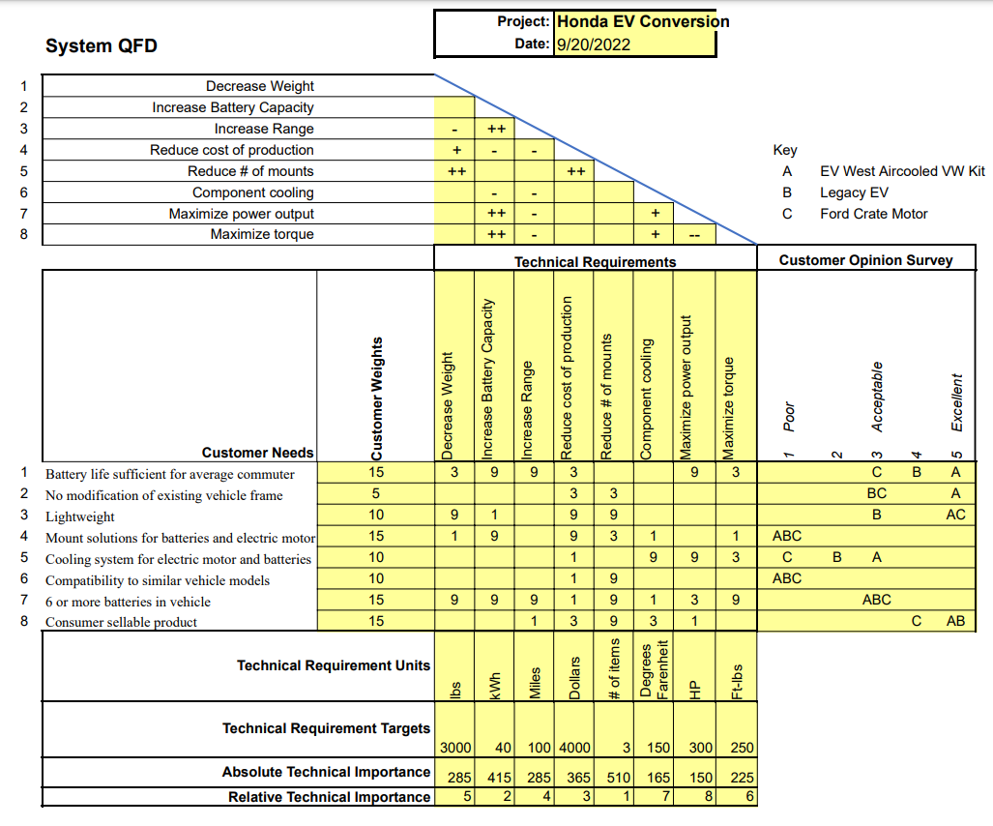
Figure 1: Quality Functional Deployment

